IC 74LS04
CP035
Image:
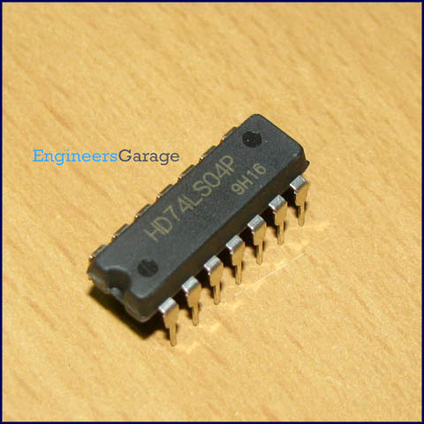
DataSheet:
74LS04.pdf
7404 is a NOT gate IC. It consists of six inverters which perform logical invert action. The output of an inverter is the complement of its input logic state, i.e., when input is high its output is low and vice versa.
Pin Diagram:
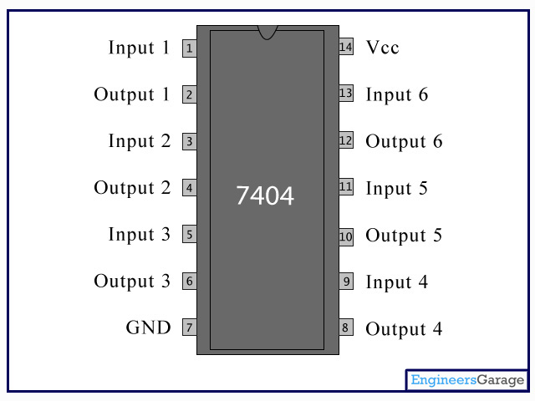
Pin Description:

Pin No | Function | Name
1 | Input/output of 1st inverter | Input1
2 | Input/output of 1st inverter | Output1
3 | Input/output of 2nd inverter | Input2
4 | Input/output of 2nd inverter | Output2
5 | Input/output of 3rd inverter | Input3
6 | Input/output of 3rd inverter | Output3
7 | Ground (0V) | Ground
8 | Output/input of 4th inverter | Output4
9 | Output/input of 4th inverter | Input4
10 | Output/input of 5th inverter | Output5
11 | Output/input of 5th inverter | Input5
12 | Output/input of 6th inverter | Output6
13 | Output/input of 6th inverter | Input6
14 | Supply voltage; 5V (4.75 - 5.25 V) | Vcc

